SPECS

ENGINE
- TYPEIn line 2 cylinders, 4-stroke, liquid cooled , 4 valves for cylinder double overhead camshaft DOHC
- DISPLACEMENT500 c.c.
- BORE X STROKEø69x66.8
- COMPRESSION RATIO11,5:1
- RATED OUTPUT35kW (48 hp) at 8500 r/min
- MAX. TORQUE46N.m/6000r/min
- LUBRICATIONForced lubrication with wet sump
- FUEL SUPPLYElectronic fuel injection with double throttle body ø 37 mm
- EXHAUST SYSTEMWith catalytic converter and oxygen sensors
- CERTIFICATIONEuro 5
- CLUTCHMultidisc wet clutch
- GEARBOX6-speed
- FINAL DRIVEChain
- IGNITIONECU - TLI
- SPARK PLUGNGK CR8E
- STARTINGElectric
- GEAR RATION/A
- PRIMARY DRIVEN/A
- FUEL CONSUMPTIONFuel consumption 3,9 l/100km
- CO2 EMISSIONSCO2 emissions: 91 g/km

CHASSIS
- FRAMETrestle steel tubes and plates
- FRONT SUSPENSIONUpside-down forks Ø 50mm
- FRONT SUSPENSION STROKEN/A
- REAR SUSPENSIONRear swing arm with central shock absorber, spring preload, hydraulic rebound and compression setting adjustable
- REAR SHOCK ABSORBER STROKEN/A
- FRONT BRAKEDouble disk ø320 mm with floating 2 pistons calliper and ABS
- FRONT RIM TYPERim and hub in Aluminum alloy with iron spokes
- FRONT RIM DIMENSIONS19” x 3.00” DOT –D
- REAR BRAKESingle disc ø260 mm with single piston floating calliper and ABS
- REAR RIM TYPERim and hub in Aluminum alloy with iron spokes
- REAR RIM DIMENSIONS17” x 4.25” DOT – D
- FRONT TYRE110/80- R19 - M/C 59V
- REAR TYRE150/70 - R17 – M/C 69V

DIMENSIONS
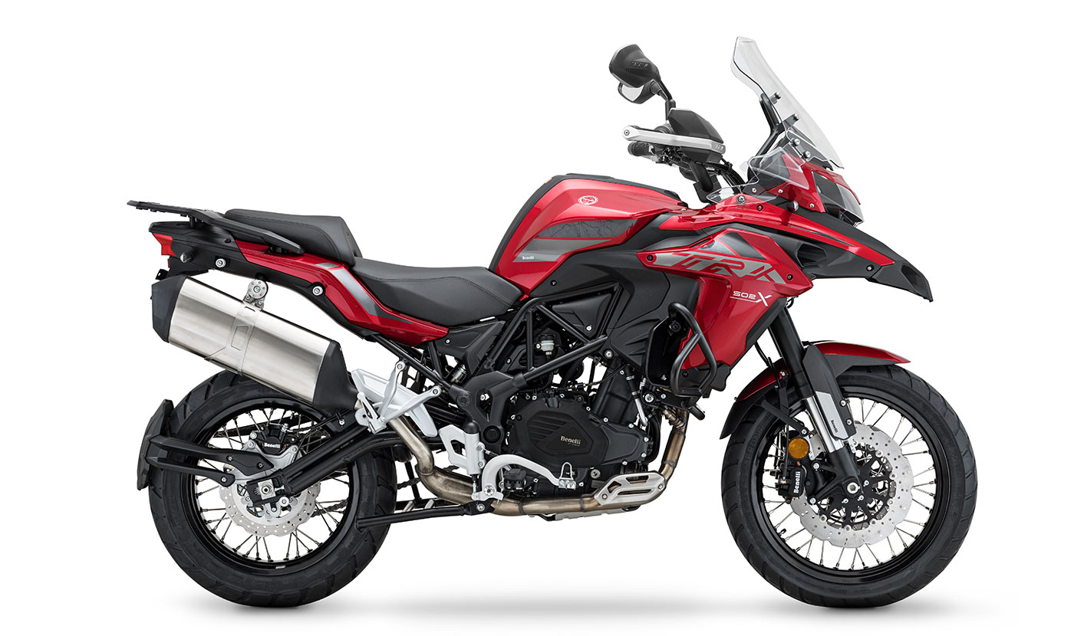
LENGTH
2200 mm
HEIGHT EXCLUDING MIRRORS
1490 mm
PILOT SEAT HEIGHT
840 mm
- WIDTH EXCLUDING MIRRORS915 mm
- GROUND CLEARANCE220 mm
- UNLADEN WEIGHT213 kg
- ROAD READY WEIGHTN/A
- PERMITTED TOTAL WEIGHTN/A
- USABLE TANK VOLUME20 lt
- RESERVE3 lt
- WHEELBASE1525 mm

